Software Requirements Specification

for

Machine Learning in Diabetes

Version 1.0

Prepared by

SAI RAJENDRA GAWAND

1.Introduction

**Document Purpose:** To detect if the person is suffering from diabetes using glucose and blood pressure as features and Diabetes as label.

**Product Scope:** helps to check if a person has diabetics

**Intended Audience:** Developer, Tester

2.Overall Description

Product Overview:

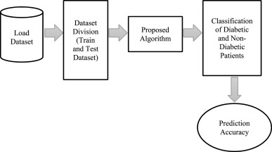

**Product Functionality:**

R1: Download data in CSV format

R2: Using pandas extract features and label from CSV file

R3: Build ML Model using ML Algorithm

R4: Predict and analyze

3.Functional Requirements

Using pandas extract features and label from CSV file

Build ML Model using ML Algorithm

4.Other Requirements N/A